
MEDH 4301-Medical/Health Humanities Critical Perspectives
through Cross-cultural Perspectives in Hispanic Poetry and Art

Syllabus-SSI 2026-4/29/26
Honors Study Abroad Program in Spain
Subject to any new Texas legislative mandate changes or other needed changes.
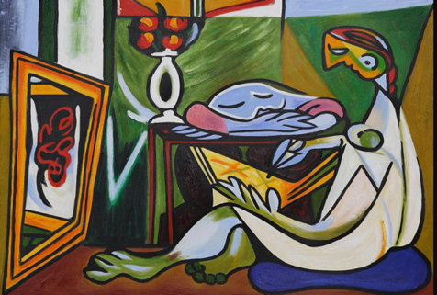
Pablo Picasso, Woman Drawing
An abstract painting of a woman drawing

“In the art of living, man is both the artist and the object of his art; he is the sculptor and the marble; the physician and the patient.” (Erich Fromm)

Course Modality Study-Abroad Program in Madrid, Spain, May 16-May 31, 2026.
Instructor Name: Dr. Suzanne LaLonde; webpage: suzannelalonde.us
UTRGV E-mail: Suzanne.lalonde@utrgv.edu Program/Course Webpage
Phone: 956 266-8891; contact me through WhatsApp
Office Location: LimeHome Apartment, 26 Calle de Ave Maria, Madrid, Spain
Office Hours: Send an email to your professor for a meeting time in the patio area of the apartment complex or a Zoom.

Course Catalogue Description, Prerequisites & Course Modality
“Students in the course will examine various topics within the field of the medical humanities, including constructions of diseases, understanding of health and illness, health practitioners, ethics, healthcare institutions, and provision and access. Course materials will vary by instructor but will be interdisciplinary, drawing on history, literature, anthropology, sociology, biology, and philosophy. They will examine and learn about major issues confronting healthcare professionals, including access, diversity, and costs.” (No prerequisites) Traditional in Spain.

Course Objectives: This interdisciplinary, experiential course has four objectives: 1) To expand students’ knowledge and appreciation of Hispanic arts (from poetry to paintings), with a special focus on cross-cultural perspectives and critical thinking. 2) To foster emotional intelligence, such as perception, compassion, and conscious awareness of oneself and others through an intense exposure to the arts. 3) To expand students’ understanding of the field of Medical/Health Humanities and to heighten their awareness of sociological and psycho-philosophical (as opposed to purely concrete and physical) topics confronting healthcare providers and the sick today. 4) To cultivate creative thinking skills by studying both art in and outside of museums and poetry during class discussions. Students will further foster and exhibit their creative thinking skills by creating a) a video documentary project “The Art and Poetry of Emotions”; b) a handwritten travel field notebook, containing musings on class content and cultural visits; c) and promo material for the documentary.
Textbook & Technology Requirements Scanned copies of Hispanic literature are compiled in a packet and are available on BrightSpace and the Webpage. In addition, you will assemble your own Field Notebook “textbook” from the material in the packet and your visits to museums, as well as your impressions of that material.
Course Grading Matrix
- Attendance & Participation–30% Attendance will be taken at the beginning of each class. (Please note: you must actively participate in the discussions to receive 2pts. for each class.)

- “The Art and Poetry of Emotions” Documentary from Spain–30%
(How to make a documentary: CAPCUT / FILMORA.WONDERSHARE / OPENART.AI)

- Handwritten Travel Field-Notebook–30%
- Uploaded Documentary and E-Poster on ScholarWorks and BrSp—10%
(How to upload your documentary and E-Poster to ScholarWorks: Video Guide recording link; here’s the site link: Scholarworks.utrgv.edu/eqhumanities )

Course Rationale: The COVID-19 pandemic brought to the forefront of our minds the pressing issue of the well-being of healthcare providers. One pertinent mental-health topic is how clinicians react emotionally to patients and to themselves as they observe and experience suffering. At the heart of the issue lies a paradox. Providers are schooled in the “art” of medicine and to practice an ethos of care built on emotional connections. However, during a pandemic when clinicians experience extreme physical exhaustion and the trauma of witnessing suffering on a massive scale, they might remain “checked out” as a form of self-protection. Objectivity, logic, and statistics can also trump feelings since an emotional connection with patients could translate into an inability to perform optimally. Yet, emotionally connected providers may have a placebo effect, as they assuage patients during recovery and encourage resilience and healing. In addition to these complex topics, it is not clear what happens to healthcare providers themselves if they are disconnected from their patients and from themselves. How do they process traumatic experiences—such as witnessing suffering, dying, and the associated moral questions—if they remain disconnected emotionally? How can they engage empathically with a patient if they struggle to understand emotionally (feel empathy for) their own traumatic experiences? In metaphorical terms, how can they help a patient in states of suffering if they themselves have experienced a type of psychic numbing? Do these questions simply point to a philosophical enigma, or do they assume an ethical dimension as well? This course aims to address the issue of psychic numbing by exposing students to emotionally provocative poetry and art and requiring them to imagine how that psycho-philosophical content relates to healthcare. After all, ideal healthcare emphasizes interpretation, reflection, and imaginative engagement with others.

SCHEDULE-Subject to Change
# | Date | Activities | Distr  Themes Themes | HW Assignments
1 | Sat, 5/16 | Travel to Madrid | Exploring the Arts, and the Medical Humanities, while Cultivating Emotional Intelligence | 1-Video Lesson #1 on BrightSpace (Take notes for a class discussion in Spain.)  2- Madrid, Madrid, Madrid, canción cantada por Agustin Lara y por Placido Dómingo  Lyrics and translation in “textbook”
2 | Sun, 5/17 | Arrival in Madrid; settle into lodging; shop for food; metro pass?; short walking tour of the neighborhood | Discovering Madrid!  Themes: Orientation and Disorientation | 1-Antonio Machado, “Caminante, no hay Camino” / “Traveler, Your Footprints”  2-Pablo Neruda,“Poesia” / “Poetry”  3-Francisco Goya, La pradera de San Isidro / The Meadow of San Isidro  (a picture of a gathering in a meadow outside of Madrid)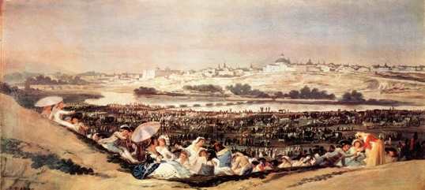
3 | Mon, 5/18 | Museo Arqueológico Nacional, & Jardines del Descubrimiento  Map of the Museum-MAN | Salamanca #5:  Theme: Origins of Human Cultural Evolution | 1-Jaime Sabines, “Adán y Eva V” / “Adam and Eve V”  2-Blas de Otero, “En el principio”/ “In the Beginning”  3-Arte prehistórico  Prehistoric art  (A picture of a bison from prehistoric art)  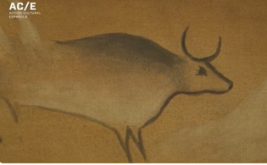
4 | Tue, 5/19 | TOLEDO: Alcázar, Cathedral, Old Synagogue, Museo de El Greco | Toledo:  Theme: Plural Truths | 1-Yehuda Halevi, “Mi corazón está en Oriente” / “My heart is in the East” (Libi baMizrach)  2-Wallada bint al-Mustakfi, Poemas “Cuando caiga la tarde” / Ibn Zaydun’s “Patience has departed…"  3-El Greco, Vista y plano de Toledo / View and Plan of Toledo  (a picture of a Toledo, Spain) 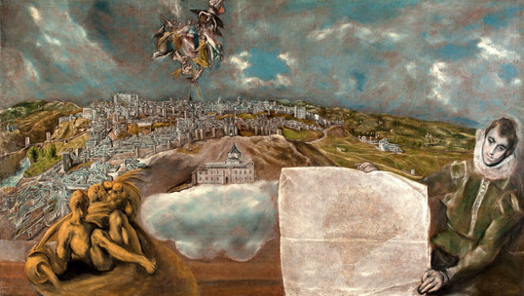
5 | Wed, 5/20 | Palacio Real, Plaza Mayor, Galería de las Colecciones Reales, &  Parque de la Montaña y del Oeste | Historical Heart of Madrid #1a:  Theme: Sacred Power | 1- Luis de Góngora, “Ilustre y hermosísima María” / “O Noble and Most High in Beauty, Thou…”  2-Fray Luis de León, “En la Ascensión” / “At the Ascension”  3- La apoteosis de la monarquía Española/ The Apotheosis of the Spanish Monarchy (Fresco, Queen’s Antechamber, Palacio Real)  (a picture of a ceiling in the Royal Palace depicting the royal family’s divinely connection)  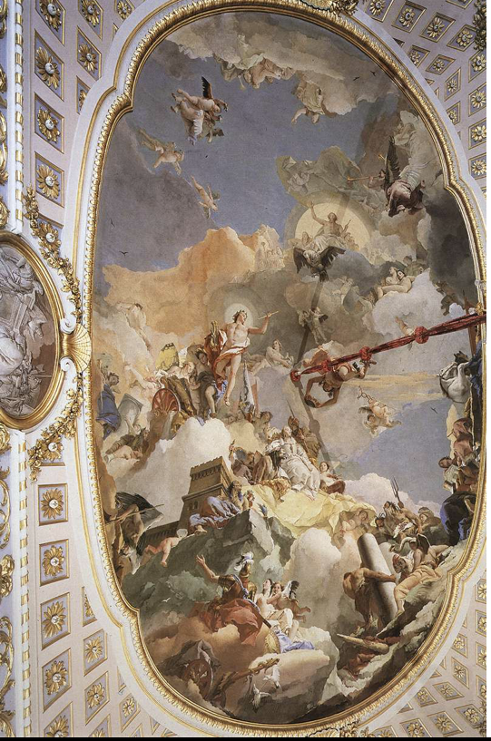
6 | Thu, 5/21 | Catedral de Santa María la Real de la Almudena,  Campo de Moro, & el Parque del Emir Mohamed I (Siege of Madrid Walk) | Historical Heart of Madrid #1b:  Theme: The Aesthetic Ideal and Transcendence | 1- Saint John of the Cross, “En una noche oscura” / “One Dismal Night”  2-Teresa of Ávila, “En perseguirme, Mundo, ¿qué interesas?” / “Oh World, Why, Do You Thus Pursue Me?”  3a-Gothic architecture of the Cathedral  (a picture of gothic architecture)  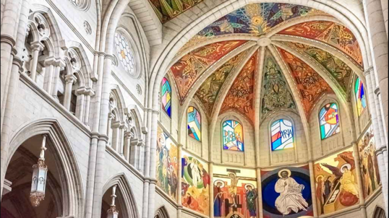  3b-Recreation of 9th-century Madrid; find remains of other buildings in Spain; those mentioned below.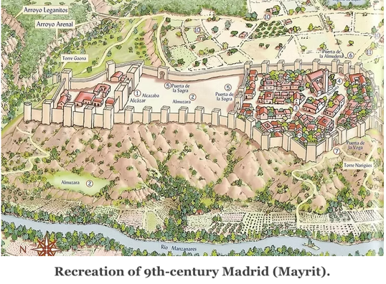  (a picture of a recreation of 9th century Madrid)
7 | Fri, 5/22 | Basilica de San Francisco el Grande, Museo de San Isidro, & Escuelas Pías de San Fernando, & Jardines de las Vistillas | La Latina & Lavapiés #2:  Theme: Pastoral Life, Urban Life, and “Civilization” | 1- Lope de Vega, “Pastor que con tus silbos amorosos…” /“Shepherd Who With Your Tender Calls…”  2-Francisco de Quevedo, “A Roma sepultada en sus ruinas” / “To Rome Entombed in Her Ruins”  3-Francisco Goya, La romería de San Isidro/ The Pilgrimage to San Isidro  (a picture of people on a pilgrimage to San Isidro)  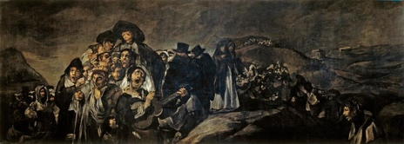
8 | Sat, 5/23 | Real Academia de Bellas Artes, Barrio de las letras, Calle de Alcala (architectural wonders), & Plaza Santa Ana | Sol, Santa Ana, Huertas #3:  Theme: Cultural Authority | 1-Miguel de Cervantes, Don Quijote/ Quixote Part I, Ch 14 ; “el poema de Grisóstomo” “Grisóstomo’s poem”  2- Diego Velázquez, Las Meninas  (a picture of a royal family gathered) 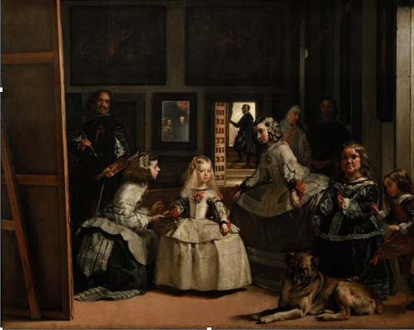
9 | Sun, 5/24 | FREE DAY  ¿El Rastro—flea market open on Sundays?  ¿ Córdoba? | FREE DAY | FREE DAY
10 | Mon, 5/25 | El Prado & el Parque del Buen Retiro | El Retiro y los museos #4a:  Theme: The Renaissance “Self” | 1-Luis de Góngora, “Alegoría de la brevedad de las cosas humanas” / “Allegory of the Brevity of Things Human”  2-Lope de Vega, / “Soneto de repente” “A Sonnet All of a Sudden”  3-El Greco’s El caballero de la mano en el pecho  (A picture of a stately figure with hand on chest)  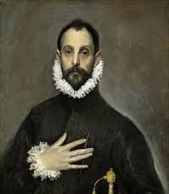
11 | Tue, 5/26 | Centro de Arte Reina Sofía, Museo Thyssen-Bornemisza, Observatory of Spain, & Real Jardín Botánico | El Retiro y los museos #4b:  Theme: Reason and its Discontents | 1-Gustavo Adolfo Bécquer, “Al ver mis horas de fiebre…” / “To See the Hours of Fever…”  2-Manuel González Prada, “Vivir y morir” / “ To Live and to Die”  3-Francisco Goya, El sueño de la razón produce monstruos  (a picture of a man suffering with tormenting bats)  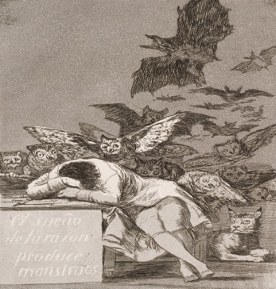
12 | Wed, 5/27 | Museo Taurino, Las Ventas, Museo Lázaro Galdiano, & Parque Florido palace | Salamanca #5:  Theme: Myth and Ritual | 1- Federico García Lorca, “Llanto por Ignacio Sánchez Mejías” / “Lament for Ignacio Sánchez Mejías” (Performed version on YouTube in Spanish.)  2- Francisco de Goya, Bullfight, Suerte de Varas  (a picture of a bullfight)  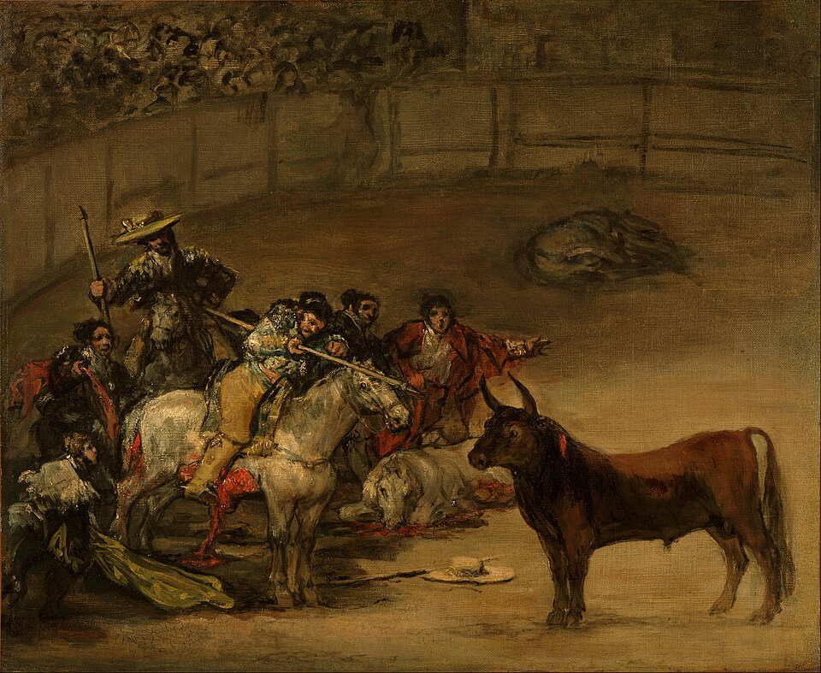
13 | Thu, 5/28 | Museo del Romanticismo Sociedad General de Autores y Editores, & Jardines Arquitecto Rivera | Chueca #6:  Theme: Romantic Revolt | 1-Manuel González Prada, “Al hogar arrojan leña”/ “Into the Hearth They Are Tossing Logs…”  2-Rosalía de Castro, “Candente está la atmósfera” / “The Atmosphere is Incandescent”  3-Leonardo Alenza y Nieto,  Sátira del suicidio romántico  (a picture of a man falling off a cliff)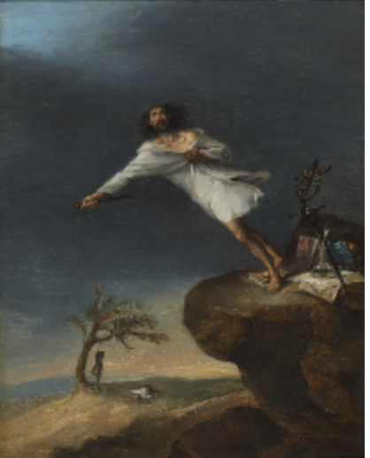
14 | Fri, 5/29 | Museo Ico, & Panteón de España | Salamanca #5 & #4  Theme: Fragmented Modernity | 1-Miguel de Unamuno, “Oración de un ateo” / “Prayer of an Atheist”  2-Pablo Neruda, “Explico algunas cosas” / “I explain a few things…”  3- Pablo Picasso, Guernica  (a picture of people, a bull and a horse, suffering)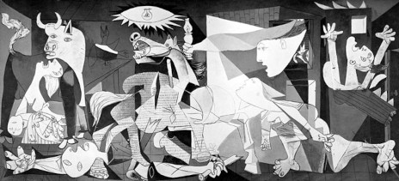
15 | Sat, 5/30 | FREE DAY | FREE DAY
16 | Sun, 5/31 | Departure from Madrid | Departure from Madrid | Video Lesson #2 by your professor on Brightspace (Take notes; material to help you with your final projects) A) Your Field-Notes Textbook from Spain; B) Your Emotional Intelligence Documentary on your travels and how you have cultivated EI; C) Your promo materials.

USE OF AI
AI provides both assets and drawbacks. On the one hand, as you work on your HW assignments, you can ask CHAT GPT to help you correct and edit what you have written. This way, you have a handy editor to perfect your writing in English as well as your creative and critical thinking skills. On the other hand, CHAT GPT can make us into robots ourselves, and this would be truly oxymoronic if this were to occur while studying literature and art and traveling in such a culturally rich epicenter as Madrid! After all, literature and art courses are designed to make us critical thinkers, so that we automatically question everything we see and hear. They also encourage us to become more creative thinkers, as we absorb sublime metaphors and images in our mind’s eye and clever word combinations that ring relentlessly in our ears. We can outfox any robot with our creative and critical thinking skills, but we need to work hard to cultivate those skills. More succinctly put, do not abuse A.I. Use it only to help perfect your writing skills and to introduce you to new avenues of research, cultivating new neuronal connections, which are as numerous as the stars in the heavens above.

UTRGV POLICIES, ETC.

STUDENTS WITH DISABILITIES
Students with a documented disability (physical, psychological, learning, or other disability that affects academic performance) who would like to receive academic accommodations should contact Student Accessibility Services (SAS) for additional information. In order for accommodation requests to be considered for approval, the student is responsible for providing sufficient documentation of the disability to SAS and participating in an interactive discussion with SAS staff. Accommodations may be requested at any time but are not retroactive. Please contact SAS early in the semester/module for guidance. Students who experience a broken bone, severe injury, or undergo surgery may also be eligible for temporary accommodations.

Pregnancy, Pregnancy-related, and Parenting Accommodations
Title IX of the Education Amendments of 1972 prohibits sex discrimination, which includes discrimination based on pregnancy, marital status, or parental status. Students seeking accommodations related to pregnancy, pregnancy-related condition, or parenting (reasonably immediate postpartum period) are encouraged to contact Student Accessibility Services for additional information and to request accommodations.

Student Accessibility Services:
Brownsville Campus: Student Accessibility Services is located in 1.107 in the Music and Learning Center building (BMSLC) and can be contacted by phone at (956) 882-7374 or via email at ability@utrgv.edu.

Edinburg Campus: Student Accessibility Services is located in 108 University Center (EUCTR) and can be contacted by phone at (956) 665-7005 or via email at ability@utrgv.edu.

MANDATORY COURSE EVALUATION PERIOD
Students are required to complete an ONLINE evaluation of this course, accessed through your UTRGV account (http://my.utrgv.edu); you will be contacted through email with further instructions. Students who complete their evaluations will have priority access to their grades. Online evaluations will be available on or about the end of June.

SCHOLASTIC DISHONESTY
As members of a community dedicated to Honesty, Integrity and Respect, students are reminded that those who engage in scholastic dishonesty are subject to disciplinary penalties, including the possibility of failure in the course and expulsion from the University. Scholastic dishonesty includes but is not limited to: cheating, plagiarism (including self-plagiarism), and collusion; submission for credit of any work or materials that are attributable in whole or in part to another person; taking an examination for another person; any act designed to give unfair advantage to a student; or the attempt to commit such acts. Since scholastic dishonesty harms the individual, all students and the integrity of the University, policies on scholastic dishonesty will be strictly enforced (Board of Regents Rules and Regulations, STU 02-100, and UTRGV Academic Integrity Guidelines). All scholastic dishonesty incidents will be reported to Student Rights and Responsibilities.

SEXUAL MISCONDUCT and MANDATORY REPORTING In accordance with UT System regulations, your instructor is a “Responsible Employee” for reporting purposes under Title IX regulations and so must report to the Office of Institutional Equity & Diversity (oie@utrgv.edu) any instance, occurring during a student’s time in college, of sexual misconduct, which includes sexual assault, stalking, dating violence, domestic violence, and sexual harassment, about which she/he becomes aware during this course through writing, discussion, or personal disclosure. More information can be found at www.utrgv.edu/equity, including confidential resources available on campus. The faculty and staff of UTRGV actively strive to provide a learning, working, and living environment that promotes personal integrity, civility, and mutual respect that is free from sexual misconduct, discrimination, and all forms of violence. If students, faculty, or staff would like confidential assistance, or have questions, they can contact OVAVP (Office for Victim Advocacy & Violence Prevention) at (956) 665-8287, (956) 882-8282, or OVAVP@utrgv.edu.

COURSE DROPS
According to UTRGV policy, students may drop any class without penalty earning a grade of DR until the official drop date. Following that date, students must be assigned a letter grade and can no longer drop the class. Students considering dropping the class should be aware of the “3-peat rule” and the “6-drop” rule so they can recognize how dropped classes may affect their academic success. The 6-drop rule refers to Texas law that dictates that undergraduate students may not drop more than six courses during their undergraduate career. Courses dropped at other Texas public higher education institutions will count toward the six-course drop limit. The 3-peat rule refers to additional fees charged to students who take the same class for the third time.

STUDENT SERVICES
Students who demonstrate financial need have a variety of options when it comes to paying for college costs, such as scholarships, grants, loans and work-study. Students should visit the Students Services Center (U Central) for additional information. U Central is located in BMAIN 1.100 (Brownsville) or ESSBL 1.145 (Edinburg) or can be reached by email (ucentral@utrgv.edu) or telephone: (888) 882-4026. In addition to financial aid, U Central can assist students with registration and admissions.

Students seeking academic help in their studies can use university resources in addition to an instructor’s office hours. University Resources include the Advising Center, Career Center, Counseling Center, Learning Center, and Writing Center. The centers provide services such as tutoring, writing help, counseling services, critical thinking, study skills, degree planning, and student employment. In addition, services such as the Food Pantry are also provided. Locations are listed below.

Center Name | Brownsville Campus | Edinburg Campus
Advising Center  AcademicAdvising@utrgv.edu | BMAIN 1.400  (956) 665-7120 | ESWKH 101  (956) 665-7120
Career Center  CareerCenter@utrgv.edu | BCRTZ 129  (956) 882-5627 | ESSBL 2.101  (956) 665-2243
Counseling Center  Counseling@utrgv.edu  Counseling and Related Services List | BSTUN 2.10  (956) 882-3897 | EUCTR 109  (956) 665-2574
Food Pantry  FoodPantry@utrgv.edu | BCAVL 101 & 102  (956) 882-7126 | EUCTR 114  (956) 665-3663
Learning Center  LearningCenter@utrgv.edu | BMSLC 2.118  (956) 882-8208 | ELCTR 100  (956) 665-2585
Writing Center  WC@utrgv.edu | BUBLB 3.206  (956) 882-7065 | ESTAC 3.119  (956) 665-2538

